COMPLETE YOUR PEDAGOGICAL COMPETENCE FORM (TO BE COMPLETED BY ENDORSING CLIENT)

PEDAGOGICAL COMPETENCe of applicant based on applied CREDIT EXEMPTION MODULES AND/OR SKILLS badges
Please rate the pedagogical skills proficiency and quality of work performed by the applicant based on the following project(s) the applicant has indicated to have performed for you. The scale serves as a guide to understanding the expected proficiency level:

0 – NA (Not Applicable);
1 – Basic (Fundamental Awareness and Knowledge);
2 – Novice (Limited Experience);
3 – Intermediate (Practical Application);
4 – Advanced (Applied Theory);
5 – Expert (Recognised Authority).
SECTION 1 – PROECT TO BE ENDORSED
Title of Project involved
(include course conducted, courseware developed, TAE-related consultation work, etc.)
Start Date |  | <Month> <Year>
End Date |  | <Month> <Year>
Target Audience |  | - Adult learners  - Company employees  - Management  - Others: Pls specify
Type of TAE involvement |  | - Diagnostic/Needs analysis  - Design/Development  - Facilitation and/or Assessment  - Coaching/Mentoring  - Others: Pls specify
Brief description of your TAE-related involvement in this project
Relevance to Skills Badges applied for |  | - Learning Experience Delivery  - Skills Framework Adoption  - Technology-enabled Learning Delivery  - Workplace Learning Facilitation  - Learning Solution Design  - Assessment Design Implementation
SKILLS BADGE | SKILLS DESCRIPTION | RATE THE PROFICIENCY LEVEL | MANDATORY COMMENTS ON THE WORK PERFORMED BY THE APPLICANT
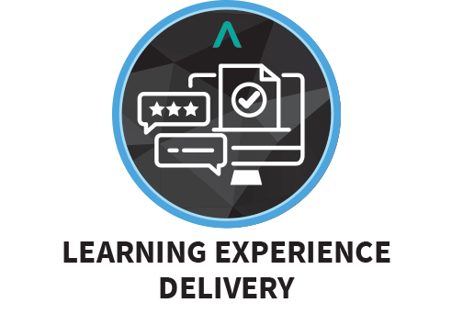  (under Delivery and Execution Skills Category) | Facilitate learning experiences which are aligned to learner needs and desired outcomes | 0 1 2 3 4 5  ☐ ☐ ☐ ☐ ☐ ☐
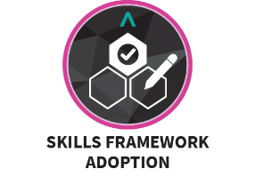  (under Intervention Design & Development Skills Category) | Drive the adoption, integration and implementation of Skills Frameworks and their components in business and human resources activities throughout the organisation | 0 1 2 3 4 5  ☐ ☐ ☐ ☐ ☐ ☐
(under Delivery and Execution Skills Category) | Implement and integrate learning technology in facilitation of learning experiences | 0 1 2 3 4 5  ☐ ☐ ☐ ☐ ☐ ☐
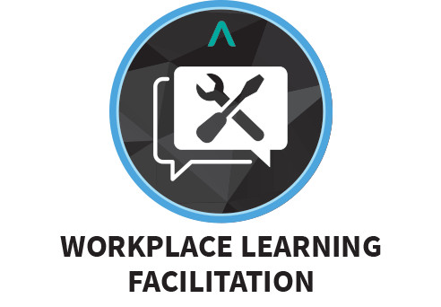  (under Delivery and Execution Skills Category) | Implement workplace learning solutions which are aligned to learner needs and contexts to drive performance | 0 1 2 3 4 5  ☐ ☐ ☐ ☐ ☐ ☐
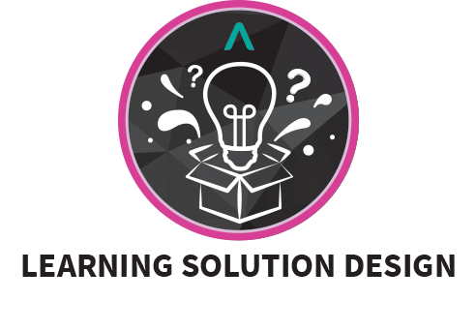  (under Intervention Design & Development Skills Category) | Design and prototype learning solutions which drive performance enhancement | 0 1 2 3 4 5  ☐ ☐ ☐ ☐ ☐ ☐
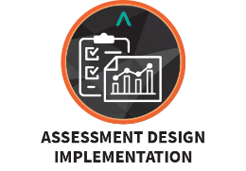  (under Impact Monitoring & Evaluation Skills Category) | Design & implement assessment methods and tools to evaluate learner progress | 0 1 2 3 4 5  ☐ ☐ ☐ ☐ ☐ ☐

Section 2: declaration BY ENDORSING ORGANISATION on the information provided above
I declare that all the information provided in this application is true to the best of my knowledge and I have not willfully suppressed any material fact.

I understand that Institute for Adult Learning (IAL) reserves the rights to decline or reject the endorsement and validation if the information is not as represented or request for more information for the accurate assessment of the skills credentials.

Salutation & Name of Organisation Representative:
Designation:
Name of Organisation:
Address of Organisation:
Contact No.:
Corporate email Address:
Signature and Company Stamp:
Date endorsed:

