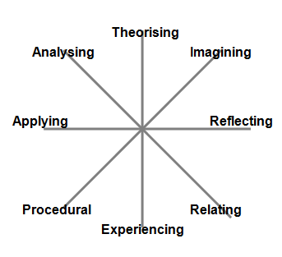

**Applying**

**Analysing**

Likes things to be logical

Seeking patterns/ looking for variables and dimensions

Using interpretative lenses

Offering critique /

deconstructing

Speculative/ look for alternatives

Risk taking /break rules

Create / design

Vision / imagine

**Imagining**

**Reflecting**

Using intuition

& empathy

Seeking personal meaning

Building relationships and

meaning with others

Likes stories, metaphors

Likes to be organised

Focusing on detail, accuracy

and precision

Following procedures and rules

Ordering and categorising

**Insight**

**Integration**

**Experiencing**

**Relating**

**Procedural**

Wanting to know the reasons behind things

Using or developing models to explain why

Determines underlying principles, dynamics and causes

Likes consistency and coherence

Working on a real problem

Putting into practice

Learning what is relevant for now and needing context

Projecting implications of actions

Needing think time

Looking for the whole, thinks holistically, relationally

Contemplation, noticing, mindfulness

Reflecting on what, how, why I do/ think/learn/be/grow

**Theorising**

Doing/making /kinaesthetic / sensual

Role playing

Conducting experiments

Seeking authentic/real experiences

**Dialogue Inquiry Model**

**1**

**2**

**3**

**Create your Inquiry Profile**

On the map below mark out those statements that resonate the most with who you are. Work out how many of each category that you have. On the map to the right mark with a dot on each axis this number, including if it is zero. Join the dots and shade in the interior of the shape that emerges.

**Reflect:** Does this represent the ways you prefer to learn or inquire? How does it compare to others’ profiles? How does it compare to opportunities for learning?