COMPLETE YOUR PEDAGOGICAL COMPETENCE FORM (TO BE COMPLETED BY ENDORSING CLIENT)

PEDAGOGICAL COMPETENCe of applicant based on applied SKILLS badges
Please rate the pedagogical skills proficiency and quality of work performed by the applicant based on the following project(s) the applicant has indicated to have performed for you. The scale serves as a guide to understanding the expected proficiency level:

0 – NA (Not Applicable);
1 – Basic (Fundamental Awareness and Knowledge);
2 – Novice (Limited Experience);
3 – Intermediate (Practical Application);
4 – Advanced (Applied Theory);
5 – Expert (Recognised Authority).
SECTION 1 – PROECT TO BE ENDORSED
Title of Project involved
(include course conducted, courseware developed, TAE-related consultation work, etc.)
Start Date |  | <Month> <Year>
End Date |  | <Month> <Year>
Target Audience |  | ☐ Adult learners  ☐ Company employees  ☐ Management  ☐ Others: Pls specify
Type of TAE involvement |  | ☐ Diagnostic/Needs analysis  ☐ Design/Development  ☐ Facilitation and/or Assessment  ☐ Coaching/Mentoring  ☐ Others: Pls specify
Brief description of your TAE-related involvement in this project
Relevance to Skills Badges applied for |  | ☐ Learning Experience Delivery  ☐ Assessment Design Implementation
AITP Industry to be endorsed for  Refer to the AOT list  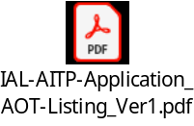 |  | [Indicate here]
SKILLS BADGE (SKILLS CATEGORY) | SKILLS DESCRIPTION | RATE THE PROFICIENCY LEVEL | MANDATORY COMMENTS ON THE WORK PERFORMED BY THE APPLICANT
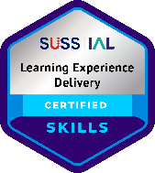  (Delivery and Execution) | Has shown proficiency in facilitating learning experiences which are aligned to learner needs and desired outcomes.
  0 | 1 | 2 | 3 | 4 | 5
  ☐ | ☐ | ☐ | ☐ | ☐ | ☐
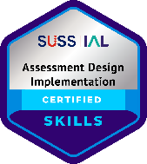  (Impact Monitoring & Evaluation) | Has shown proficiency in designing and implementing assessment methods and tools to evaluate learner progress.
  0 | 1 | 2 | 3 | 4 | 5
  ☐ | ☐ | ☐ | ☐ | ☐ | ☐

Section 2: declaration BY ENDORSING ORGANISATION on the information provided above
I declare that all the information provided in this application is true to the best of my knowledge and I have not willfully suppressed any material fact.

I understand that Institute for Adult Learning (IAL) reserves the rights to decline or reject the endorsement and validation if the information is not as represented or request for more information for the accurate assessment of the skills credentials.

Salutation & Name of Organisation Representative:
Designation:
Name of Organisation:
Address of Organisation:
Contact No.:
Corporate email Address:
Signature and Company Stamp:
Date endorsed:

