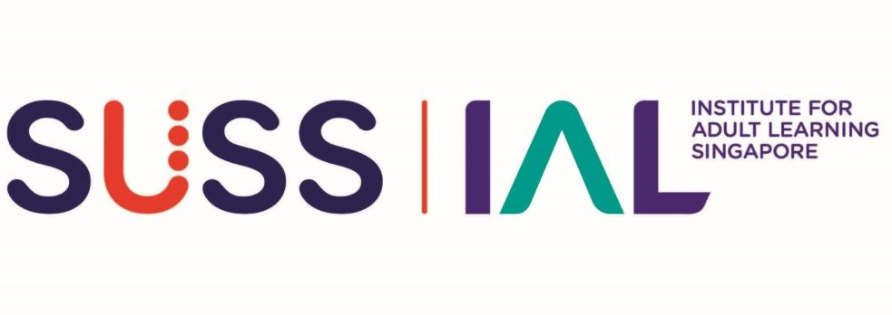

ONE-STOP SKILLS CREDENTIALING - SKILLS BADGE
Self-Assessment Form

Badge Title:
REFLECTIVE PRACTICE

SALUTATION**  ** Delete accordingly | Mr / Miss / Mdm / Ms / Dr / Prof
FULL NAME (as per NRIC)*
*Underline Surname

IMPORTANT: Before you submit this Self-Assessment Form, please save this Word document and rename using the following naming convention:

For Stage 1 Advisory Chat:
OSSC_Skills_Badge_DDDLP01_RPP_Self Assessment_YOUR FULL NAME_v1.2_draft.doc

For Stage 2 Assessment Interview:
OSSC_Skills_Badge_DDDLP01_RPP_Self Assessment_YOUR FULL NAME_v1.2_FINAL.doc

To proceed to Stage 2 Assessment Interview…
- Collate all relevant evidence/artefact pertaining to your finalised Self-Assessment Form in a single folder and name the folder according to the Badge Title as stated above.
- If applying for more than one skills badge, submission should be done in separate folders according to the badge titles.
To be completed by Advisor:
NAME OF ADVISOR
ADVISORY CHAT SESSION | Date: (dd/mm/yyyy)
Proceed to Skills Assessment? | ☐ Yes | ☐ No
☐ I confirm I have completed Stage 1 of the OSSC Skills Badging Application: Skills Advisory for BASIC Package (1 hr).
☐ I confirm I have completed Stage 1 of the OSSC Skills Badging Application: Skills Advisory for EXTENDED Package (2 hr).

IMPACT MONITORING AND EVALUATION: REFLECTIVE PRACTICE
(A)  Competency Statement  Read carefully to ensure you meet ALL requirements | (B)  Product Evidence  Check the boxes to confirm that you currently have the required evidence listed here | (C)  Applicant’s Note of Explanation  Note the given pointers to guide you in the preparation for the Skills Advisory and Assessment Interview sessions. Explain with brief notes to explain how the Product Evidence you intend to submit fulfils the requirements of columns (A) and (B). | (D)  Assessor’s comments  (For IAL use only)
1. Identify and assume roles and responsibilities and the future skills of Adult Educators based on industry and market trends and reflective practice trends | ☐ E-portfolio in one of the following forms:  - Web-based portfolio  - Multi-media portfolio  - Blog-based portfolio  Note to Applicant:  In your E-portfolio, you should include and share your:  - Journals/diary of career and professional highlights  - Continuous professional Development (CPD) programmes attended and key learnings gained in your professional development journey.  - Self-development plan, goals and means for professional improvement | Based on my E-portfolio, I am ready to reflect, articulate and discuss at the interview, the following:  ☐ My views about my professional beliefs, the desired attributes, and my roles and responsibility as an Adult Educator (AE), giving specific examples of how I live out my beliefs and responsibility.  ☐ My thoughts, reflections and responses towards the impact of technological disruptions, and of the changing trends in education.  ☐ What and how I have anticipated future skills required of an AE and how I have responded /am responding to them.  ☐ My take and understanding of reflective practice and its impact on learning process  Applicant’s Notes: | For Assessor’s comments
2. Identify opportunity areas for overall learning in practice deployed across the lifecycle of learning activities including reflective practices | ☐ A learning programme that I have designed, developed AND/OR facilitated upon which I have recorded my own reflections in practice across the life cycle of learning activities. | I am able to point out from my submitted programme:  ☐ Where and how I have used the reflective approach to identify opportunity areas for improving on overall learning practices deployed across the lifecycle of learning activities in the programme.  Applicant to Note:  In the interview, you should be prepared to  - Locate your reflective experiences and conclusions within your recent AE work lifecycle depicted in your submitted programme (e.g., in design, implementation, etc.) and describe how you have reflected on issues arising using RP approaches/methods.  - Identify new insights gained when using a different approach/method to reflect on the same experience.  - Describe the process and conclusion(s) of your reflection on your own learning practice. And point out how it has progressively affected your submitted learning programme. Point out specific opportunities for learning and how the reflective practice helped you to discover them.  Applicant’s Notes:
3. Adopt reflective practice methods for overall learning practices across the lifecycle of learning activities. | ☐ A learning programme that I have designed, developed AND/OR facilitated upon which I have recorded my own reflective practice approaches. | ☐ I can point out specific learning activities within the programme to elaborate on how I have adopted and applied at least TWO (2) reflective practice approaches.  ☐ I can share my reflection processes and the conclusions and decisions I have arrived at, and the actions I have taken since.  Applicant’s notes:  ☐ I can point out where I have adopted appropriate reflective practice methods deployed across my learning activities within my submitted programme and explain why I selected each approach or method.  Note to Applicant:  Be prepared to evaluate the approach and/or method used and justify your decision and preference to use it in the context of your practice.  Applicant’s notes:  ☐ I can describe the learners’ responses to the reflective practice activities that I have included in my programme, my own conclusions of whether it has assisted learning, and how the reflective practice could be adjusted for greater learner effectiveness.  Applicant’s Notes:
4. Evaluate achievement of learning goals to identify ways of improving own overall learning practices and professional/career development as an AE. | ☐ As in the rows above, including a comprehensive and coherent self-development plan in the E-Portfolio. | I am able to submit evidence that shows the evaluation of my own learning, and it includes:  ☐ Reflection on TWO (2) current competency AND/OR learning goals, defining the following:  - My areas of strength  - My areas for improvement  - Ways to change or adapt my practice to include reflective practice  - Timelines to achieve the intended outcomes  My submitted self-development plan incorporated the following:  ☐ Intended/ongoing development of professional capability  ☐ AT LEAST THREE (3) elements of SMART framework and/or within a coherently structured clearly thought-out plan.  Note to Applicant:  SMART goals is defined by the following characteristics:  - Specific: Targeted efforts that could be tracked and measured  - Metacognitive: Should include considerations of assumption and beliefs  - Affective: Includes social and psychological aspects of planning the goal  - Relevant: Aligned to your professional values, professional objectives, and work context  - Time-based: Has a realistic timeline to manage prioritization and goal achievement  Applicant’s Notes:  ☐ Methods of evaluation of learning goals  Note to Applicant:  The methods of evaluation may include evidence of the following adaptation of Bloom’s, Kolb’s, AND/OR Atkin’s models:  - Journalling  - Critical Incidences Analysis  - Self-reflection and Self-Questioning  - Collaborative Reflective Practice  - Dialogical Self and Dialogue, etc.  Applicant’s Notes:  ☐ A structured approach that assessed the different aspects of my E-Portfolio/career journey.  ☐ Measure of progress towards the achievement of my defined milestones and career developmental goals  ☐ Description, reflection and elaboration of progress made.  Applicant’s Notes:

